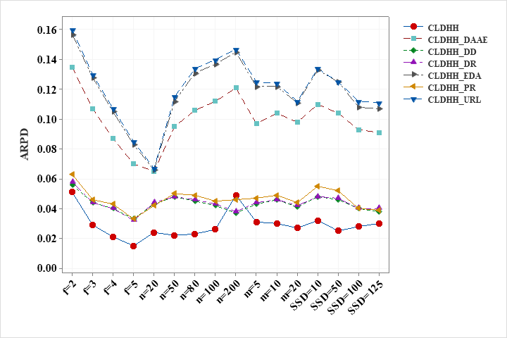

|  |  |  |  |  |  |  |  |  |
| --- | --- | --- | --- | --- | --- | --- | --- | --- |
|  |  | CLDHH_UpperRL | CLDHH_  EDA | CLDHH_DD | CLDHH_  PR | CLDHH_  DR | CLDHH_  DAAE | CLDHH |
| $$f$$ | 2 | 0.160 | 0.157 | 0.056 | 0.063 | 0.058 | 0.135 | **0.051** |
| 3 | 0.130 | 0.128 | 0.044 | 0.046 | 0.044 | 0.107 | **0.029** |
| 4 | 0.107 | 0.105 | 0.040 | 0.043 | 0.040 | 0.087 | **0.021** |
| 5 | 0.085 | 0.083 | 0.033 | 0.033 | 0.032 | 0.070 | **0.015** |
| $$n$$ | 20 | 0.067 | 0.066 | 0.043 | 0.042 | 0.044 | 0.065 | **0.024** |
| 50 | 0.115 | 0.112 | 0.048 | 0.050 | 0.048 | 0.095 | **0.022** |
| 80 | 0.134 | 0.131 | 0.045 | 0.049 | 0.046 | 0.106 | **0.023** |
| 100 | 0.140 | 0.137 | 0.042 | 0.045 | 0.043 | 0.112 | **0.026** |
| 200 | 0.147 | 0.145 | **0.037** | 0.046 | 0.038 | 0.121 | 0.049 |
| $$m$$ | 5 | 0.125 | 0.122 | 0.043 | 0.047 | 0.044 | 0.097 | **0.031** |
| 10 | 0.124 | 0.122 | 0.046 | 0.049 | 0.046 | 0.104 | **0.030** |
| 20 | 0.112 | 0.111 | 0.041 | 0.044 | 0.042 | 0.098 | **0.027** |
| $$SSD$$ | 10 | 0.134 | 0.133 | 0.048 | 0.055 | 0.048 | 0.110 | **0.032** |
| 50 | 0.125 | 0.125 | 0.046 | 0.052 | 0.047 | 0.104 | **0.025** |
| 100 | 0.112 | 0.108 | 0.040 | 0.040 | 0.040 | 0.093 | **0.028** |
| 125 | 0.111 | 0.107 | 0.038 | 0.039 | 0.040 | 0.091 | **0.030** |
| Mean |  | 0.121 | 0.118 | 0.043 | 0.046 | 0.044 | 0.100 | **0.029** |

|  |  |  |  |  |  |  |
| --- | --- | --- | --- | --- | --- | --- |
| vs. | $$R+$$ | $$R-$$ | $$Z$$ | $$p-value$$ | $$α=0.1$$ | $$α=0.05$$ |
| CLDHH_URL | 443211 | 0 | -26.57 | 0.00E+00 | $$YES$$ | $$YES$$ |
| CLDHH_EDA | 444146 | 7 | -26.59 | 0.00E+00 | $$YES$$ | $$YES$$ |
| CLDHH_DD | 364023 | 78247 | -17.16 | 0.00E+00 | $$YES$$ | $$YES$$ |
| CLDHH_PR | 380592 | 62619 | -19.06 | 0.00E+00 | $$YES$$ | $$YES$$ |
| CLDHH_DR | 370065 | 73145 | -17.80 | 0.00E+00 | $$YES$$ | $$YES$$ |
| CLDHH_DAAE | 443951 | 202 | -26.56 | 0.00E+00 | $$YES$$ | $$YES$$ |